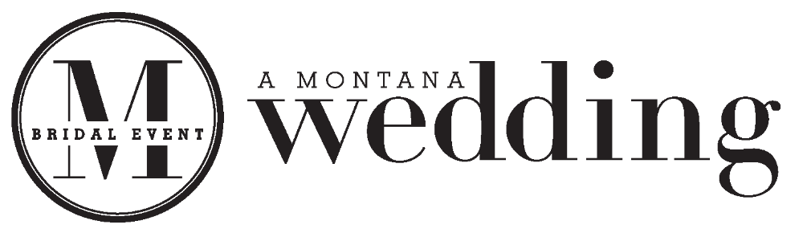Vendor Guide
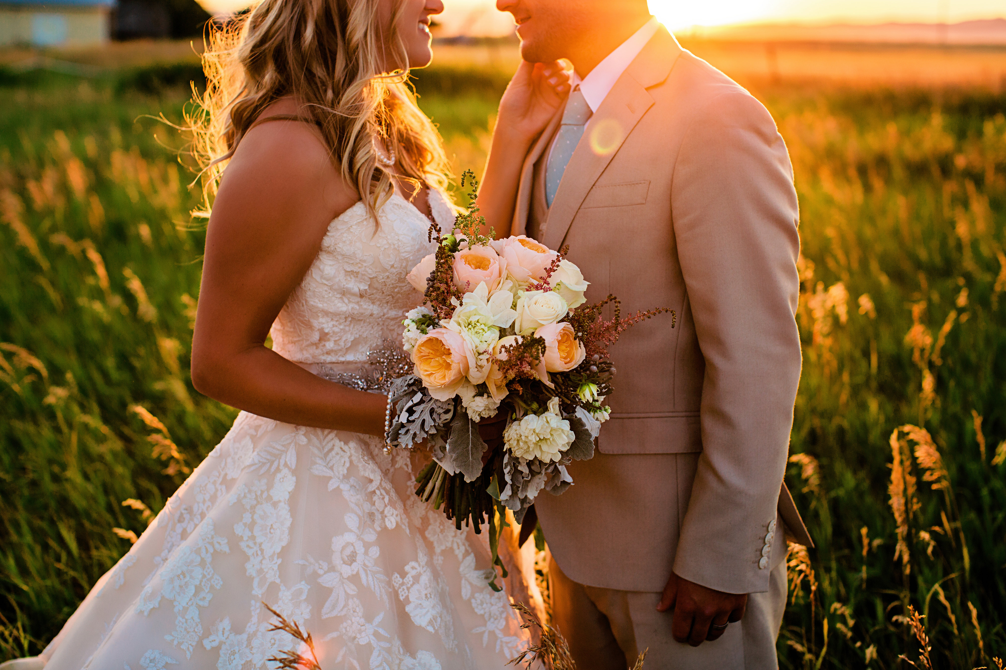

Saturday, February 18, 2017

10:00am – 3:00pm

What makes A Montana Wedding the Best Return on Your Investment?

Advertising Power
You have the power of the Bozeman Daily Chronicle, both in print and online.

Event Program
On Wednesday, February 14, we will insert the program in the Daily Chronicle. The event program will be distributed at the event too, along with A Montana Wedding magazine. The event program will list the name of your business and location of your booth.

Event Promotion
There will be radio ads, the Montana Wedding Event program, email blasts, Facebook posts, Pinterest board pinnings and advertising in regional publications, all to drive traffic to the event.

Lead List
You will receive a lead list of attending brides after the event.

We're Local...
Our goal is to help Montana vendors grow their business and keep client's dollars in Montana.

Important Vendor Information

The Bozeman Daily Chronicle would like to thank you for your participation in our annual bridal event.

This guide contains important vendor information. Please read it thoroughly, as it should provide answers to most questions you might have about the event. Please let us know if you have any further questions.

Event Coordinator: Leslie McCleary, 406.582.2699, lmccleary@dailychronicle.com
….............................................................................................................................................

Show Date and Time
A Montana Wedding Event
Saturday, February 18, 2017, 10:00am to 3:00pm
The Commons at Baxter & Love Lane

Load In and Set Up
Friday, February 17, 2017 from 3:00pm to 7:00pm.
Saturday, February 18, 2017 from 8:00am to 9:30am.

Vendors may start setting up on Friday, February 17, at 3:00pm and on Saturday, February 18, at 8:00am. We strongly recommend vendors plan to set up on Friday. There will be more time for set up on Friday. Saturday morning and no pressure to be ready for opening! The event team and The Commons host will be available to answer questions and provide help when needed.

On Saturday, February 18, vendors are asked to be in attendance by 9:45am. All booths must be ready by 9:30am. Doors open at 10:00am.

Please note: Parking in front of The Commons entrance is only while you are unloading or loading. As soon as you are finished, you will need to move your vehicle to a parking space at the rear of the parking lot along Baxter Lane.

The Commons has a back entrance to the auditorium. For booths around the stage area, this will be the most convenient entrance to use for unloading and loading. The front entrance slopes up to the main doors. This makes it convenient for booths located in the front lobby and back end of the auditorium.

You will be responsible for getting your items in and out. Please be considerate of others. Unload and move your vehicle from the entrance before setting up your booth.

Decorating will begin on Friday. Be sure you have everything you need for the event. This includes power cord and extension cords.

Load Out
Saturday, February 18, 2017 after 3:00pm or as soon as the public has exited the venue.

The load out begins when the event ends at 3:00pm or after the public has left the event. Please do not break down and move things out of the venue during the event. This is distracting and you may miss an opportunity to meet an attendee who is coming back to your booth on the way out of the event. If you break down before the event is over, you may be in violation of the rules and may not be allowed to participate in future events. Once again, please be considerate of others. Have all items broken down and packed before bringing your vehicle to the entrance.

Before leaving the venue, be sure to check out with Leslie McCleary or a member of the event team.

Ticket Sales
Tickets are $5.00 if purchased prior to the event, and $10.00 at the door. Attendees may also purchase their tickets online at: http://www.montanaweddingevent.com/

Booth Displays
Be creative with your booth. You don't need to bring everything from the store to make the booth great. Keep it simple and elegant, and remember to invite brides to stop by and look at your booth.

Fire regulations prevent the use of any open flame candles. Vendors may use battery operated candles. If you have a wooden structure as part of your display, ensure that it has a fire-protected coating.

Tasting Booths may offer samples of food. Any other edible items for event attendees must be prepackaged, such as prewrapped, bite-sized candy.

Each vendor will be provided with a sign for their booth. If you need electrical connection in your booth, please let Leslie McCleary know and bring a power cord and extension cords.

Prizes and Giveaways
Throughout the day winner’s name will be drawn for giveaways. The Grand Prize Winner will be drawn at the end of the Fashion Show. Only the Grand Prize Winner does not have to be present to win.

If you would like to participate in the drawings, please contact Leslie McCleary at 406.582.2699 or lmccleary@dailychronicle.com. Donated giveaway items will be listed with the corresponding vendor’s name in the event program. Prior to announcing the winner, the emcee will announce the donating vendor's name.

As each bride-to-be enters the event, she will be given a gift tote bag. Vendors are encouraged to provide future brides who visit their booth with a giveaway and/or literature about their business.

Fashion Show
The Fashion Show will be held at 1:30pm in the auditorium. If you would like to participate in the fashion show, contact Leslie McCleary.

Montana Wedding Bistro
Food and drink will be sold by local eateries and food trucks and available in the Montana Wedding Bistro. There will be a bar providing alcoholic and non-alcoholic drinks and a Water Station in the lobby. ID carding will be done at the ticket tables. Attendees ages 21 and older will be given one color of wrist band. Attendees 20 and under will be given another.

Event Contract
Contracts must be completed and sent in at the time the booth(s) is reserved. Vendors can email, fax or mail their signed contracts to:

Bozeman Daily Chronicle
Leslie McCleary
2820 W. College
Bozeman, MT 59718
406.582.2699
FAX: 406.582.2658
lmccleary@dailychronicle.com

Other Things to Remember
- Be courteous, respectful and careful when moving in and out.
- If your booth does not require a table and/or chairs please contact Leslie McCleary at 406.582.2699 or lmccleary@dailychronicle.com.
- Please do not break down early.
- Please do not leave any trash or items behind in your booth. Before leaving be sure to check out with Leslie McCleary or a member of the event team.

Make Your Booth the Most Popular at the Show

Be creative with your booth
Keep it simple and elegant. Do bring samples of your work and products to display.

Think neatness & visibility when setting up your booth
Make sure your display is organized and tidy. Future brides will be turned off by messiness or having to search to find what they want. Make it easy for visitors to get information. Use signs in your display to provide basic information.

Pull a crowd to your booth
Use an interactive display, such as a quiz or game on the computer, a contest drawing or a demonstration at your booth. It doesn't need to be fancy to draw people's attention and get them to cluster around your booth.

Offer a giveaway
Participating in the giveaway drawings is a great way to help the attendees remember your business. Remember, they will have an event bag to keep your giveaway safe till they get home.

Make sure you have plenty of promotional literature on hand
Have a good supply of flyers or brochures, as well as business cards. Be prepared to book appointments. Be ready to do business.

Have your booth manned at all times
Someone needs to be there to greet future brides, engage them with conversation and answer questions. Vendors must wear the vendor ID tags at all times. If you need to leave your booth unattended, use the “Will Return in a Moment” sign provided.

Actively engage booth visitors
Congratulate the future bride! This will make them feel special, as it is a special time in their lives. Give people who approach your booth a friendly welcome, and let them know you encourage questions. Be sure your body language is friendly. Don't sit behind the table or stand with your arms crossed in front of your chest. Be prepared to provide specifics to questions.

Follow up promptly
Right after the event, send an email or make phone calls to follow up with the brides you meet at the event. The sooner you initiate the communication, the better chance you have of generating business. It doesn't have to be expensive. A personal handwritten note speaks volumes about your service.

